AI Assisted Coding Lab Assignment - 20.5
Name : G.Sarayu
Hall.t.No. : 2303A51014
Batch No. : 01

Lab 20 – Security Testing: Identifying Vulnerabilities in AI- Generated Code
Lab Objectives:
- Understand how to test AI-generated code for common security vulnerabilities.
- Learn to apply secure coding principles while analyzing AI outputs.
- Practice detecting risks such as SQL injection, XSS, hardcoded credentials, and weak encryption.
- Enhance code reliability and safety by using AI for secure refactoring.

Task 1 – Password Storage Vulnerability Check
Task: Analyze an AI-generated signup script for insecure password storage.
Instructions:
- Prompt AI to generate a Python user registration program.
- Check whether passwords are stored in plain text.
- Improve the script using hashing (bcrypt or hashlib).
Expected Output:
- A secure registration script with hashed password storage.

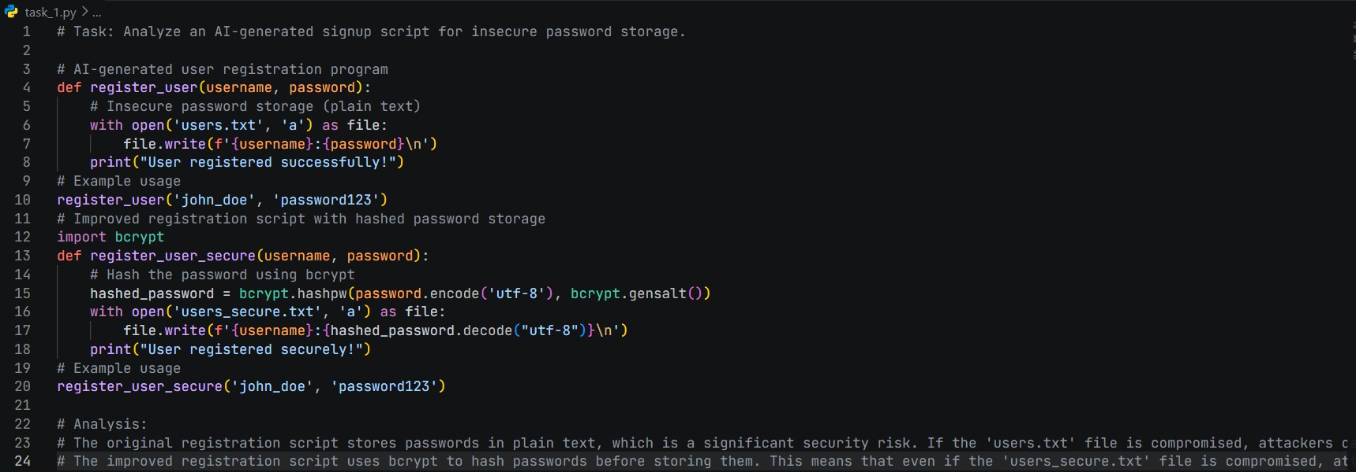

Task 2 – Hardcoded Secrets Detection
Task: Evaluate AI-generated code for hardcoded API keys or credentials.
Instructions:
- Ask AI to generate a script that connects to an external API.
- Identify if API keys/passwords are written directly in code.
- Refactor using environment variables or config files.
Expected Output:
- A secure script with secrets managed properly.

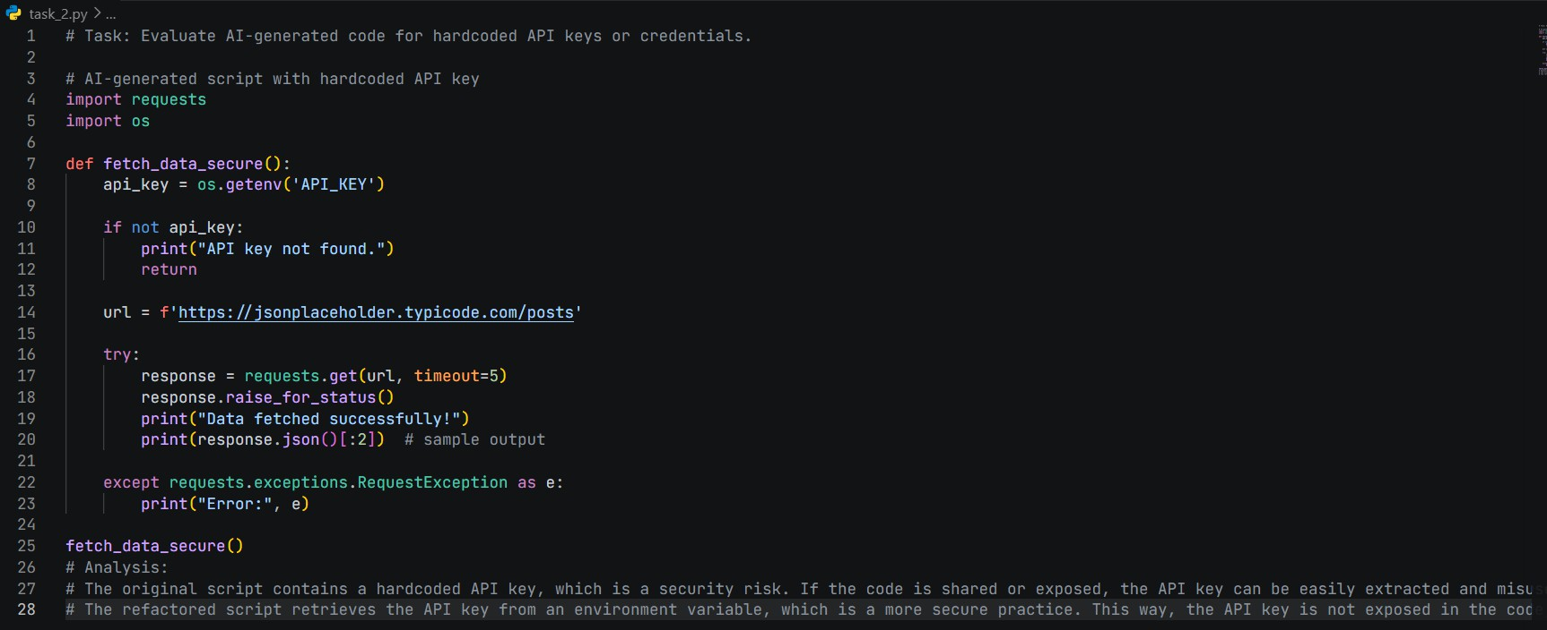

Task 3 – File Upload Security Validation
Task: Test an AI-generated file upload program for unsafe file handling. Instructions:
- Prompt AI to generate a Flask file upload example.
- Check for vulnerabilities like uploading executable files.
- Add validation for file type, size, and secure filename Handling.
Expected Output:
- A secure file upload implementation.

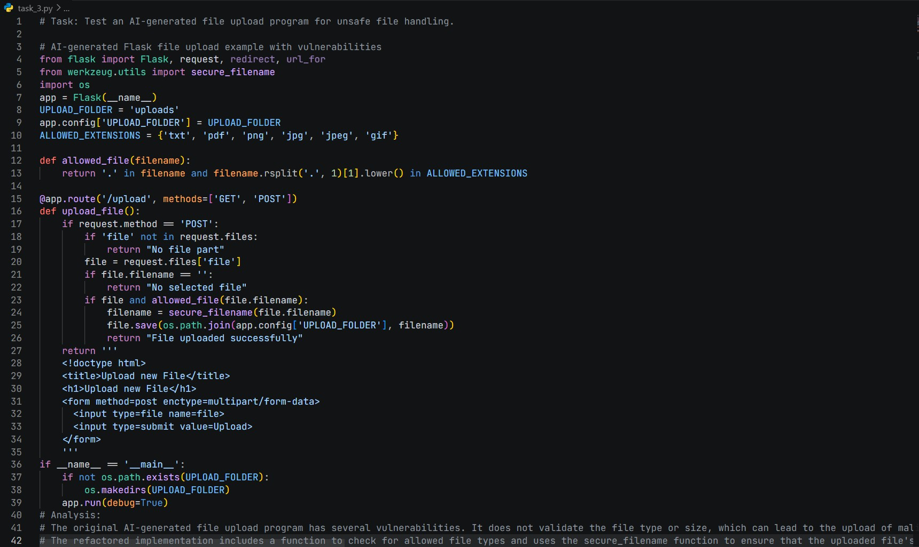

Task 4 – Command Injection Prevention
Task: Analyze an AI-generated Python script that executes system commands.
Instructions:
- Ask AI to generate code using os.system() or subprocess.
- Identify command injection risks with user input.
- Fix using safe subprocess calls and input validation.
Expected Output:
- A secure command execution script.

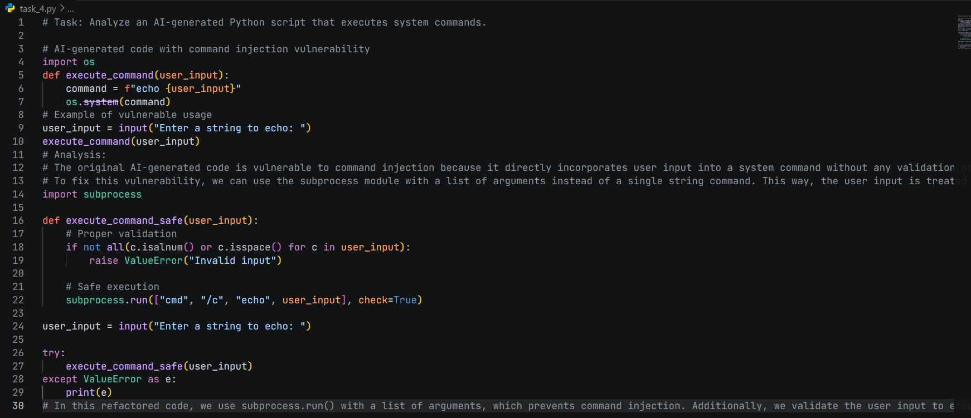

Task 5 – Secure Input Handling in Web Forms
Task: Check AI-generated web form code for improper input validation. Instructions:
- Ask AI to generate an HTML + Flask feedback form.
- Identify missing validation and unsafe rendering.
- Fix using server-side validation and sanitization.
Expected Output:
- A secure form resistant to injection attacks.

